# Dr. ZAKIR HUSAIN COLLEGE, ILAYANKUDI

# P.G DEPARTMENT OF MATHEMATICS

# UNCOVERING THE GAMING INDUSTRY’S HIDDEN GEMS

## Submitted by,

|  |  |  |  |
| --- | --- | --- | --- |
| Name of the student | University Reg.No: | Naanmudhalvan ID | Smartinternz team ID |
| B. Sneha | 0620121044 | asalu6620121044 | NM2023TMID07721 |
| K. Azhagu priyanka | 0620121007 | asalu6620121007 | NM2023TMID07721 |
| N. Balasoundharya | 0620121009 | asalu6620121009 | NM2023TMID07721 |
| S. Linthiya | 0620121025 | asalu6620121025 | NM2023TMID07721 |

## FACULTY INCHARGE,

## Dr. B. FATHIMA KANI,

## ASSISTANT PROFESSOR,

## DEPARTMENT OF MATHEMATICS,

## Dr. ZAKIR HUSAIN COLLEGE, ILAYANKUDI

1. INTRODUCTION

# 1.1 OVERVIEW

## Video game have been around for decades, providing entertainment for children and adults alike. They have evolved significantly from the early days of computer games and the first versions of Nintendo and Atari. The days of pixelated screens and limited sounds are a distant memory as video games have become more lifelike than ever. As technology continues to improve, so do video games. Video game creation has become increasingly complex, and the cost of creating a game to run on one of the major consoles has risen with this greater complexity. It was once unthinkable to sink millions into development costs, but games today can cost tens and even hundreds of millions. This has pushed game development into Hollywood movie territory in terms of production and marketing cost.

# PURPOSE

## provide a fun and social form of entertainment. encourage teamwork and cooperation when played with others. make kids feel comfortable with technology—particularly important for girls, who don’t use technology as much as boys. increase children’s self-confidence and self-esteem as they master games. provide points of common interest and opportunities for socialization. develop skills in reading, math, technology and problem-solving. encourage participation in related offline activities, such as reading or sports. encourage civic participation. improve hand-eye co-ordination and fine motor skills

2. PROBLEM DEFINITION & DESIGN THINKING

# 2.1 EMPATHY MAP

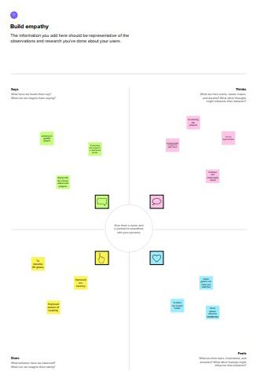

2.2 IDEATION & BRAINSTROMING MAP

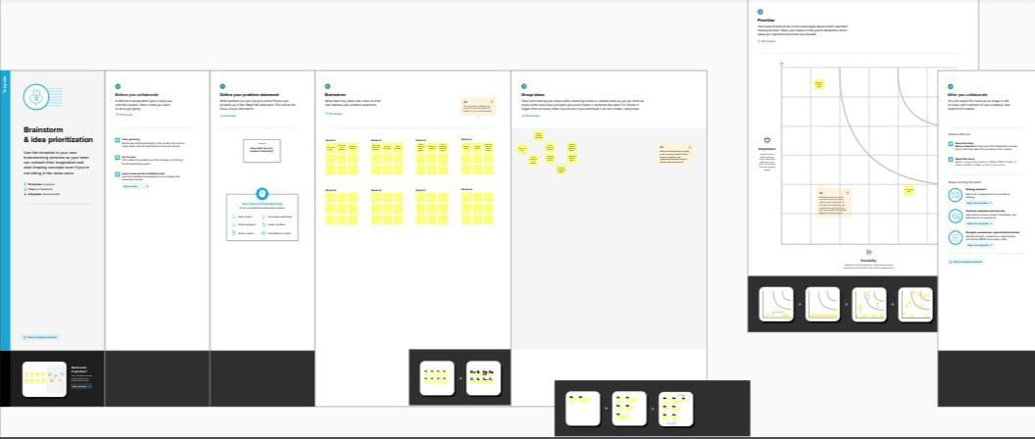

3. RESULT

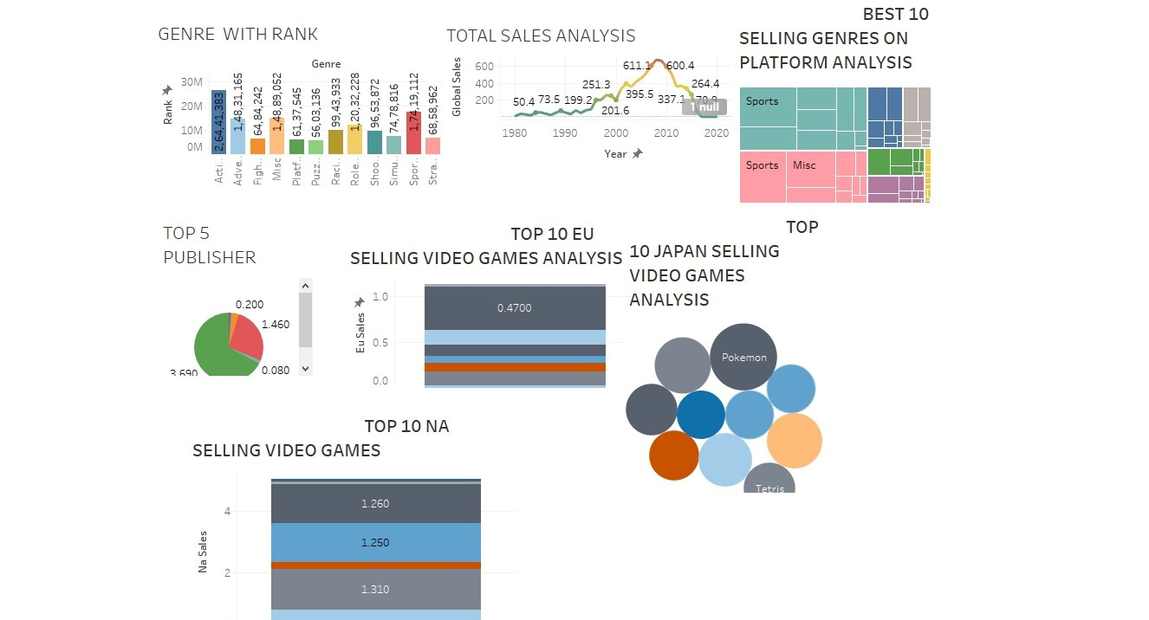

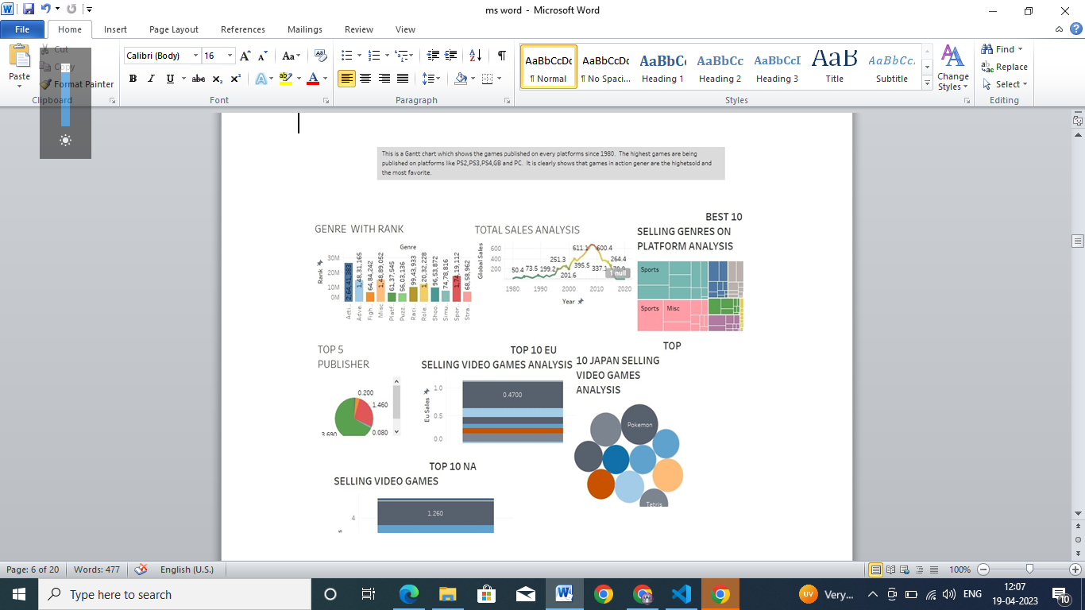

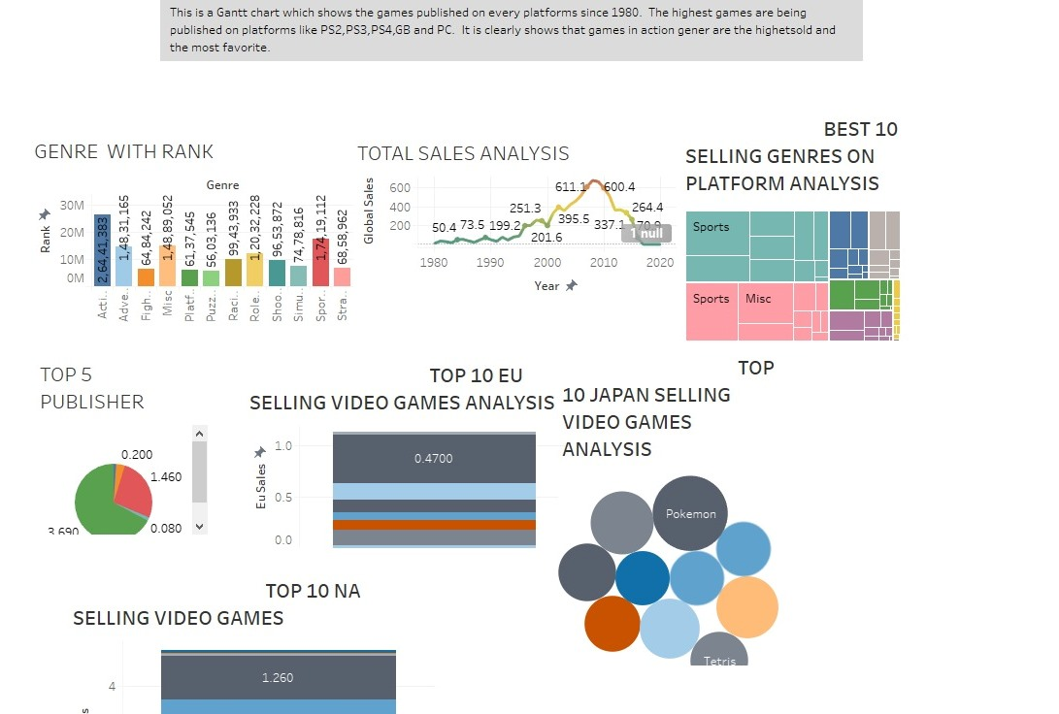

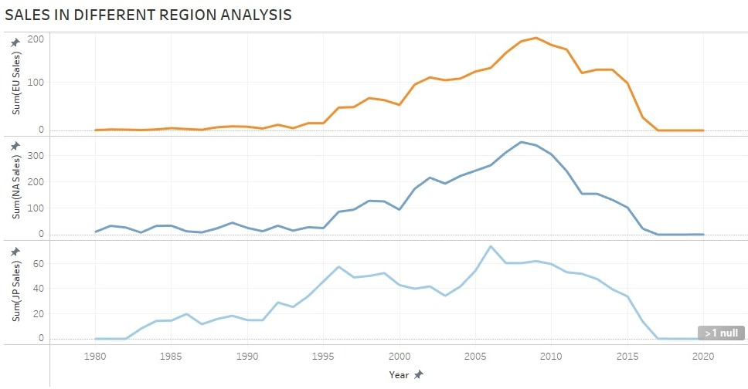

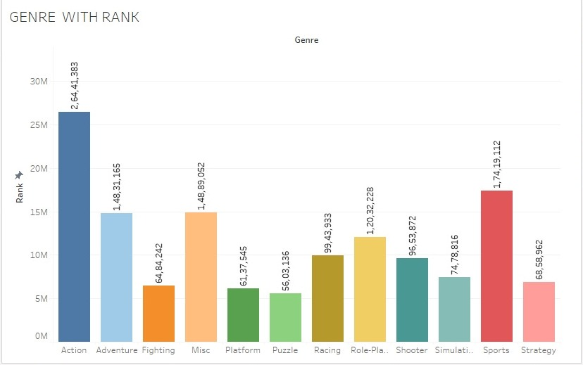

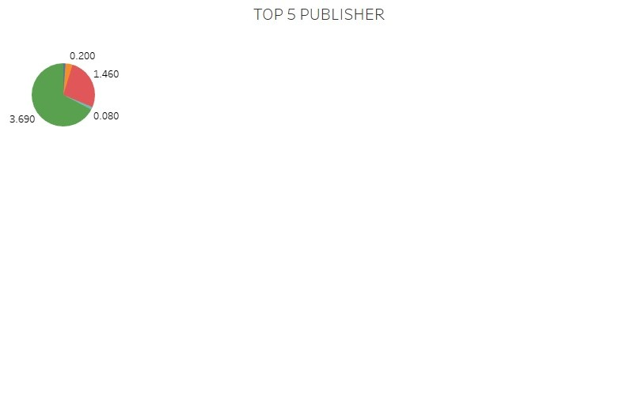

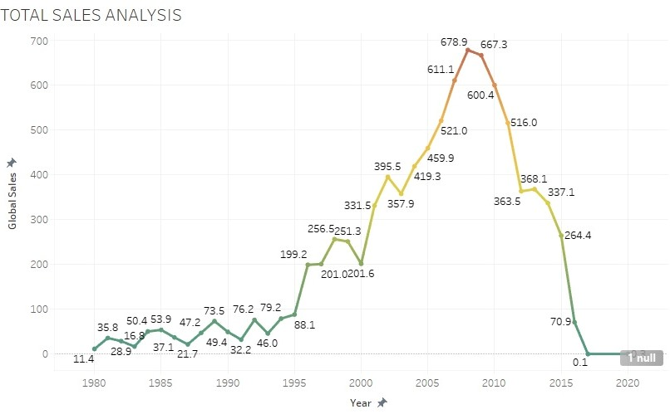

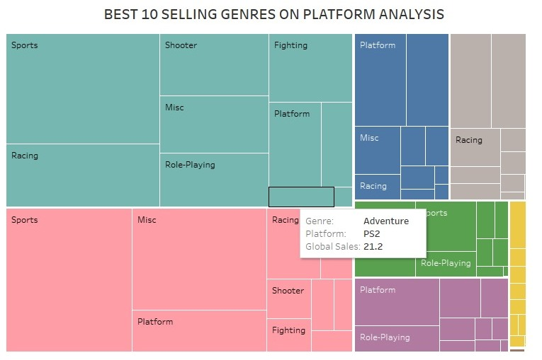

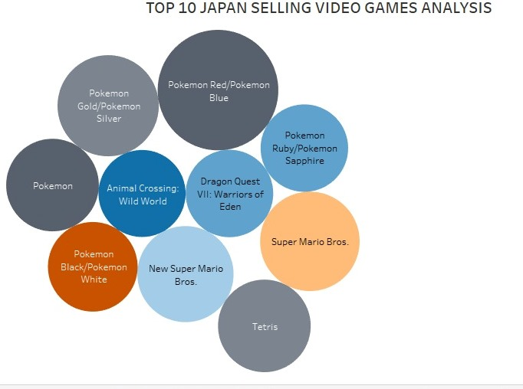

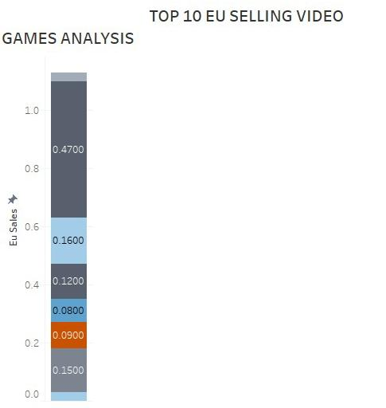

4. ADVANTAGES

The developer added a lot of new features to its game and launched it on new generation consoles. The popularity of the game exploded, causing servers to collapse, literally. Gaming consoles have become a major attraction among young and adults. People tend to design their homes considering a gaming zone and have a separate space for gaming. As far as choosing the right gaming console is concerned, Playstation is arguably one of the best in the business

DISADVANTAGES

# Spending excessive time on online games can lead to physical health issues, such as poor posture, carpal tunnel syndrome, headaches, and eye strain. Additionally, it can also lead to poor mental health, including anxiety disorders and depression. Video games can be a great recreational hobby. However, video game addiction can lead to several issues. The negative effects of video games include effects on our mind, body relationships, job performance, and more.

5. APPLICATION

# Gaming industry has undergone a huge change in the last few years. With the advent of more and more advanced technology and comprehensive gadgets, the gaming industry has adapted these to make more adaptive and realistic games. However, when we speak of the gaming industry the kind of devices and the features which are used are different. The devices used in gaming particularly are crafted based on a particular kind of game, there are sensor based devices combined with wearables making the character move in the game just like how the player moves in reality in some kind of games.

6. CONCLUSION

# In conclusion, we believe video games do have the nature to change the way someone learns. Video games are influential and have a tendency to affect those who play them. There have been many studies reinforcing this fact, and as the number of games increases, the power of its influence will too.

7. FUTURE SCOPE

## video games have [steadily risen](https://www.visualcapitalist.com/wp-content/uploads/2020/11/history-of-gaming-by-revenue-share-full-size.html) in popularity for years. And with the [social benefits of video games](https://builtin.com/media-gaming/online-gaming-social-benefits) becoming more apparent, the trend has only accelerated. Gaming is now a bigger industry than [movies and sports combined](https://www.marketwatch.com/story/videogames-are-a-bigger-industry-than-sports-and-movies-combined-thanks-to-the-pandemic-11608654990). Video games have seen it all, starting from arcade and single gaming consoles to making their way into our mobile phones and daily lives. If you are looking to enter the gaming industry, this article is the perfect guide to help you begin your journey.

8. APPENDIX

# A. SOUECE CODE

!DOCTYPE html>

<html lang="en">

<head>

  <meta charset="utf-8">

  <meta content="width=device-width, initial-scale=1.0" name="viewport">

  <title>Video Games Sales Analysis</title>

  <meta content="" name="description">

  <meta content="" name="keywords">

  <!-- Favicons -->

  <link href="assets/img/favicon.png" rel="icon">

  <link href="assets/img/apple-touch-icon.png" rel="apple-touch-icon">

  <!-- Google Fonts -->

  <link href="https://fonts.googleapis.com/css?family=Open+Sans:300,300i,400,400i,600,600i,700,700i|Raleway:300,300i,400,400i,500,500i,600,600i,700,700i|Poppins:300,300i,400,400i,500,500i,600,600i,700,700i" rel="stylesheet">

  <!-- Vendor CSS Files -->

  <link href="assets/vendor/aos/aos.css" rel="stylesheet">

  <link href="assets/vendor/bootstrap/css/bootstrap.min.css" rel="stylesheet">

  <link href="assets/vendor/bootstrap-icons/bootstrap-icons.css" rel="stylesheet">

  <link href="assets/vendor/boxicons/css/boxicons.min.css" rel="stylesheet">

  <link href="assets/vendor/glightbox/css/glightbox.min.css" rel="stylesheet">

  <link href="assets/vendor/remixicon/remixicon.css" rel="stylesheet">

  <link href="assets/vendor/swiper/swiper-bundle.min.css" rel="stylesheet">

  <!-- Template Main CSS File -->

  <link href="assets/css/style.css" rel="stylesheet">

  <!-- =======================================================

  * Template Name: Presento - v3.9.1

  * Template URL: https://bootstrapmade.com/presento-bootstrap-corporate-template/

  * Author: BootstrapMade.com

  * License: https://bootstrapmade.com/license/

  ======================================================== -->

</head>

<body>

  <!-- ======= Header ======= -->

  <header id="header" class="fixed-top d-flex align-items-center">

    <div class="container d-flex align-items-center">

      <h3 class="logo me-auto"><a href="index.html">VIDEO GAMES SALES ANALYSIS<span>.</span></a></h3>

      <!-- Uncomment below if you prefer to use an image logo -->

      <!-- <a href="index.html" class="logo me-auto"><img src="assets/img/logo.png" alt=""></a>-->

      <nav id="navbar" class="navbar order-last order-lg-0">

        <ul>

          <li><a class="nav-link scrollto active" href="#hero">Home</a></li>

          <li><a class="nav-link scrollto" href="#dashboar">Prologue</a></li>

          <li><a class="nav-link scrollto" href="#story">Challenge</a></li>

          <li><a class="nav-link scrollto " href="#portfolio">Charts</a></li>

          <li><a class="nav-link scrollto" href="#team">Dashboard</a></li>

          <li><a class="nav-link scrollto" href="#Story">Story</a></li>

          <li><a class="nav-link scrollto" href="#Report">Conclusion</a></li>

        <!--  <li class="dropdown"><a href="#"><span>Drop Down</span> <i class="bi bi-chevron-down"></i></a>

            <ul>

              <li><a href="#">Drop Down 1</a></li>

              <li class="dropdown"><a href="#"><span>Deep Drop Down</span> <i class="bi bi-chevron-right"></i></a>

                <ul>

                  <li><a href="#">Deep Drop Down 1</a></li>

                  <li><a href="#">Deep Drop Down 2</a></li>

                  <li><a href="#">Deep Drop Down 3</a></li>

                  <li><a href="#">Deep Drop Down 4</a></li>

                  <li><a href="#">Deep Drop Down 5</a></li>

                </ul>

              </li>

              <li><a href="#">Drop Down 2</a></li>

              <li><a href="#">Drop Down 3</a></li>

              <li><a href="#">Drop Down 4</a></li>

            </ul>

          </li>

          <li><a class="nav-link scrollto" href="#contact">Contact</a></li>

        </ul>

        <i class="bi bi-list mobile-nav-toggle"></i>

      </nav> .navbar -->

    </div>

  </header><!-- End Header -->

  <!-- ======= Hero Section ======= -->

  <section id="hero" class="d-flex align-items-center">

    <div class="container" data-aos="zoom-out" data-aos-delay="100">

      <div class="row">

        <div class="col-xl-6">

          <h1>A Tableau Presentation</h1>

                   <a href="#dashboard" class="btn-get-started scrollto">Get Started</a>

        </div>

      </div>

    </div>

  </section><!-- End Hero -->

  <main id="main">

    <!-- ======= Clients Section =======

    <section id="clients" class="clients">

      <div class="container" data-aos="zoom-in">

        <div class="clients-slider swiper">

          <div class="swiper-wrapper align-items-center">

            <div class="swiper-slide"><img src="assets/img/clients/client-1.png" class="img-fluid" alt=""></div>

            <div class="swiper-slide"><img src="assets/img/clients/client-2.png" class="img-fluid" alt=""></div>

            <div class="swiper-slide"><img src="assets/img/clients/client-3.png" class="img-fluid" alt=""></div>

            <div class="swiper-slide"><img src="assets/img/clients/client-4.png" class="img-fluid" alt=""></div>

            <div class="swiper-slide"><img src="assets/img/clients/client-5.png" class="img-fluid" alt=""></div>

            <div class="swiper-slide"><img src="assets/img/clients/client-6.png" class="img-fluid" alt=""></div>

            <div class="swiper-slide"><img src="assets/img/clients/client-7.png" class="img-fluid" alt=""></div>

            <div class="swiper-slide"><img src="assets/img/clients/client-8.png" class="img-fluid" alt=""></div>

          </div>

          <div class="swiper-pagination"></div>

        </div>

      </div>

    </section><!-- End Clients Section -->

    <!-- =======  dashboard Section ======= -->

    <div class='tableauPlaceholder' id='viz1681798673408' style='position: relative'><noscript><a href='#'><img alt='Dashboard 1 ' src='https:&#47;&#47;public.tableau.com&#47;static&#47;images&#47;ne&#47;new_Dashboard_16811360036670&#47;Dashboard1&#47;1_rss.png' style='border: none' /></a></noscript><object class='tableauViz'  style='display:none;'><param name='host_url' value='https%3A%2F%2Fpublic.tableau.com%2F' /> <param name='embed_code_version' value='3' /> <param name='site_root' value='' /><param name='name' value='new_Dashboard_16811360036670&#47;Dashboard1' /><param name='tabs' value='no' /><param name='toolbar' value='yes' /><param name='static_image' value='https:&#47;&#47;public.tableau.com&#47;static&#47;images&#47;ne&#47;new_Dashboard_16811360036670&#47;Dashboard1&#47;1.png' /> <param name='animate_transition' value='yes' /><param name='display_static_image' value='yes' /><param name='display_spinner' value='yes' /><param name='display_overlay' value='yes' /><param name='display_count' value='yes' /><param name='language' value='en-US' /></object></div>                <script type='text/javascript'>                    var divElement = document.getElementById('viz1681798673408');                    var vizElement = divElement.getElementsByTagName('object')[0];                    if ( divElement.offsetWidth > 800 ) { vizElement.style.width='1000px';vizElement.style.height='827px';} else if ( divElement.offsetWidth > 500 ) { vizElement.style.width='1000px';vizElement.style.height='827px';} else { vizElement.style.width='100%';vizElement.style.height='2277px';}                     var scriptElement = document.createElement('script');                    scriptElement.src = 'https://public.tableau.com/javascripts/api/viz_v1.js';                    vizElement.parentNode.insertBefore(scriptElement, vizElement);                </script>

    </section><!-- End dashboard Section -->

    <!-- ======= Counts Section ======= -->

    <!--<section id="counts" class="counts">

      <div class="container" data-aos="fade-up">

        <div class="row">

          <div class="col-lg-3 col-md-6">

            <div class="count-box">

              <i class="bi bi-emoji-smile"></i>

              <span data-purecounter-start="0" data-purecounter-end="232" data-purecounter-duration="1" class="purecounter"></span>

              <p>Happy Clients</p>

            </div>

          </div>

          <div class="col-lg-3 col-md-6 mt-5 mt-md-0">

            <div class="count-box">

              <i class="bi bi-journal-richtext"></i>

              <span data-purecounter-start="0" data-purecounter-end="521" data-purecounter-duration="1" class="purecounter"></span>

              <p>Projects</p>

            </div>

          </div>

          <div class="col-lg-3 col-md-6 mt-5 mt-lg-0">

            <div class="count-box">

              <i class="bi bi-headset"></i>

              <span data-purecounter-start="0" data-purecounter-end="1463" data-purecounter-duration="1" class="purecounter"></span>

              <p>Hours Of Support</p>

            </div>

          </div>

          <div class="col-lg-3 col-md-6 mt-5 mt-lg-0">

            <div class="count-box">

              <i class="bi bi-people"></i>

              <span data-purecounter-start="0" data-purecounter-end="15" data-purecounter-duration="1" class="purecounter"></span>

              <p>Hard Workers</p>

            </div>

          </div>

        </div>

      </div>

    </section> End Counts Section -->

    <!-- ======= Tabs Section ======= -->

    <!--<section id="tabs" class="tabs">

      <div class="container" data-aos="fade-up">

        <ul class="nav nav-tabs row d-flex">

          <li class="nav-item col-3">

            <a class="nav-link active show" data-bs-toggle="tab" data-bs-target="#tab-1">

              <i class="ri-gps-line"></i>

              <h4 class="d-none d-lg-block">Modi sit est dela pireda nest</h4>

            </a>

          </li>

          <li class="nav-item col-3">

            <a class="nav-link" data-bs-toggle="tab" data-bs-target="#tab-2">

              <i class="ri-body-scan-line"></i>

              <h4 class="d-none d-lg-block">Unde praesenti mara setra le</h4>

            </a>

          </li>

          <li class="nav-item col-3">

            <a class="nav-link" data-bs-toggle="tab" data-bs-target="#tab-3">

              <i class="ri-sun-line"></i>

              <h4 class="d-none d-lg-block">Pariatur explica nitro dela</h4>

            </a>

          </li>

          <li class="nav-item col-3">

            <a class="nav-link" data-bs-toggle="tab" data-bs-target="#tab-4">

              <i class="ri-store-line"></i>

              <h4 class="d-none d-lg-block">Nostrum qui dile node</h4>

            </a>

          </li>

        </ul>

        <div class="tab-content">

          <div class="tab-pane active show" id="tab-1">

            <div class="row">

              <div class="col-lg-6 order-2 order-lg-1 mt-3 mt-lg-0" data-aos="fade-up" data-aos-delay="100">

                <h3>Voluptatem dignissimos provident quasi corporis voluptates sit assumenda.</h3>

                <p class="fst-italic">

                  Lorem ipsum dolor sit amet, consectetur adipiscing elit, sed do eiusmod tempor incididunt ut labore et dolore

                  magna aliqua.

                </p>

                <ul>

                  <li><i class="ri-check-double-line"></i> Ullamco laboris nisi ut aliquip ex ea commodo consequat.</li>

                  <li><i class="ri-check-double-line"></i> Duis aute irure dolor in reprehenderit in voluptate velit.</li>

                  <li><i class="ri-check-double-line"></i> Ullamco laboris nisi ut aliquip ex ea commodo consequat. Duis aute irure dolor in reprehenderit in voluptate trideta storacalaperda mastiro dolore eu fugiat nulla pariatur.</li>

                </ul>

                <p>

                  Ullamco laboris nisi ut aliquip ex ea commodo consequat. Duis aute irure dolor in reprehenderit in voluptate

                  velit esse cillum dolore eu fugiat nulla pariatur. Excepteur sint occaecat cupidatat non proident, sunt in

                  culpa qui officia deserunt mollit anim id est laborum

                </p>

              </div>

              <div class="col-lg-6 order-1 order-lg-2 text-center" data-aos="fade-up" data-aos-delay="200">

                <img src="assets/img/tabs-1.jpg" alt="" class="img-fluid">

              </div>

            </div>

          </div>

          <div class="tab-pane" id="tab-2">

            <div class="row">

              <div class="col-lg-6 order-2 order-lg-1 mt-3 mt-lg-0">

                <h3>Neque exercitationem debitis soluta quos debitis quo mollitia officia est</h3>

                <p>

                  Ullamco laboris nisi ut aliquip ex ea commodo consequat. Duis aute irure dolor in reprehenderit in voluptate

                  velit esse cillum dolore eu fugiat nulla pariatur. Excepteur sint occaecat cupidatat non proident, sunt in

                  culpa qui officia deserunt mollit anim id est laborum

                </p>

                <p class="fst-italic">

                  Lorem ipsum dolor sit amet, consectetur adipiscing elit, sed do eiusmod tempor incididunt ut labore et dolore

                  magna aliqua.

                </p>

                <ul>

                  <li><i class="ri-check-double-line"></i> Ullamco laboris nisi ut aliquip ex ea commodo consequat.</li>

                  <li><i class="ri-check-double-line"></i> Duis aute irure dolor in reprehenderit in voluptate velit.</li>

                  <li><i class="ri-check-double-line"></i> Provident mollitia neque rerum asperiores dolores quos qui a. Ipsum neque dolor voluptate nisi sed.</li>

                  <li><i class="ri-check-double-line"></i> Ullamco laboris nisi ut aliquip ex ea commodo consequat. Duis aute irure dolor in reprehenderit in voluptate trideta storacalaperda mastiro dolore eu fugiat nulla pariatur.</li>

                </ul>

              </div>

              <div class="col-lg-6 order-1 order-lg-2 text-center">

                <img src="" alt="" class="img-fluid">

              </div>

            </div>

          </div>

          <div class="tab-pane" id="tab-3">

            <div class="row">

              <div class="col-lg-6 order-2 order-lg-1 mt-3 mt-lg-0">

                <h3>Voluptatibus commodi ut accusamus ea repudiandae ut autem dolor ut assumenda</h3>

                <p>

                  Ullamco laboris nisi ut aliquip ex ea commodo consequat. Duis aute irure dolor in reprehenderit in voluptate

                  velit esse cillum dolore eu fugiat nulla pariatur. Excepteur sint occaecat cupidatat non proident, sunt in

                  culpa qui officia deserunt mollit anim id est laborum

                </p>

                <ul>

                  <li><i class="ri-check-double-line"></i> Ullamco laboris nisi ut aliquip ex ea commodo consequat.</li>

                  <li><i class="ri-check-double-line"></i> Duis aute irure dolor in reprehenderit in voluptate velit.</li>

                  <li><i class="ri-check-double-line"></i> Provident mollitia neque rerum asperiores dolores quos qui a. Ipsum neque dolor voluptate nisi sed.</li>

                </ul>

                <p class="fst-italic">

                  Lorem ipsum dolor sit amet, consectetur adipiscing elit, sed do eiusmod tempor incididunt ut labore et dolore

                  magna aliqua.

                </p>

              </div>

              <div class="col-lg-6 order-1 order-lg-2 text-center">

                <img src="assets/img/tabs-3.jpg" alt="" class="img-fluid">

              </div>

            </div>

          </div>

          <div class="tab-pane" id="tab-4">

            <div class="row">

              <div class="col-lg-6 order-2 order-lg-1 mt-3 mt-lg-0">

                <h3>Omnis fugiat ea explicabo sunt dolorum asperiores sequi inventore rerum</h3>

                <p>

                  Ullamco laboris nisi ut aliquip ex ea commodo consequat. Duis aute irure dolor in reprehenderit in voluptate

                  velit esse cillum dolore eu fugiat nulla pariatur. Excepteur sint occaecat cupidatat non proident, sunt in

                  culpa qui officia deserunt mollit anim id est laborum

                </p>

                <p class="fst-italic">

                  Lorem ipsum dolor sit amet, consectetur adipiscing elit, sed do eiusmod tempor incididunt ut labore et dolore

                  magna aliqua.

                </p>

                <ul>

                  <li><i class="ri-check-double-line"></i> Ullamco laboris nisi ut aliquip ex ea commodo consequat.</li>

                  <li><i class="ri-check-double-line"></i> Duis aute irure dolor in reprehenderit in voluptate velit.</li>

                  <li><i class="ri-check-double-line"></i> Ullamco laboris nisi ut aliquip ex ea commodo consequat. Duis aute irure dolor in reprehenderit in voluptate trideta storacalaperda mastiro dolore eu fugiat nulla pariatur.</li>

                </ul>

              </div>

              <div class="col-lg-6 order-1 order-lg-2 text-center">

                <img src="assets/img/tabs-4.jpg" alt="" class="img-fluid">

              </div>

            </div>

          </div>

        </div>

      </div>

    </section>End Tabs Section -->

    <!-- ======= story Section ======= -->

    <div class='tableauPlaceholder' id='viz1681799189146' style='position: relative'><noscript><a href='#'><img alt='Story 3 ' src='https:&#47;&#47;public.tableau.com&#47;static&#47;images&#47;ne&#47;new_story_16811374891210&#47;Story3&#47;1_rss.png' style='border: none' /></a></noscript><object class='tableauViz'  style='display:none;'><param name='host_url' value='https%3A%2F%2Fpublic.tableau.com%2F' /> <param name='embed_code_version' value='3' /> <param name='site_root' value='' /><param name='name' value='new_story_16811374891210&#47;Story3' /><param name='tabs' value='no' /><param name='toolbar' value='yes' /><param name='static_image' value='https:&#47;&#47;public.tableau.com&#47;static&#47;images&#47;ne&#47;new_story_16811374891210&#47;Story3&#47;1.png' /> <param name='animate_transition' value='yes' /><param name='display_static_image' value='yes' /><param name='display_spinner' value='yes' /><param name='display_overlay' value='yes' /><param name='display_count' value='yes' /><param name='language' value='en-US' /></object></div>                <script type='text/javascript'>                    var divElement = document.getElementById('viz1681799189146');                    var vizElement = divElement.getElementsByTagName('object')[0];                    vizElement.style.width='1016px';vizElement.style.height='991px';                    var scriptElement = document.createElement('script');                    scriptElement.src = 'https://public.tableau.com/javascripts/api/viz_v1.js';                    vizElement.parentNode.insertBefore(scriptElement, vizElement);                </script>

    </section><!-- End Story Section -->

    <!-- ======= Portfolio Section ======= -->

    <section id="portfolio" class="portfolio">

      <div class="container" data-aos="fade-up">

        <div class="section-title">

          <h2>Analysis Charts</h2>

          <p>This data consists of 16599 records with 11 columns.The visualization is done using Tableau and contains 9 analysis charts.</p>

        </div>

        <div class="row" data-aos="fade-up" data-aos-delay="100">

          <div class="col-lg-12 d-flex justify-content-center">

            <ul id="portfolio-flters">

              <li data-filter="*" class="filter-active">All</li>

              <li data-filter=".filter-app">Sales</li>

              <li data-filter=".filter-card">Genre</li>

              <li data-filter=".filter-web">Publishers</li>

            </ul>          </div>

        </div>

        <div class="row portfolio-container" data-aos="fade-up" data-aos-delay="200">

          <div class="col-lg-4 col-md-6 portfolio-item filter-app">

            <div class="portfolio-wrap">

              <img src="assets/img/portfolio/portfolio-1.jpg" class="img-fluid" alt="">

              <div class="portfolio-info">

                <h4>Total sales</h4>

                <div class="portfolio-links">

                  <a href="assets/img/portfolio/portfolio-1.jpg" data-gallery="portfolioGallery" class="portfolio-lightbox" title="App 1"><i class="bx bx-plus"></i></a>

                </div>

              </div>

            </div>

          </div>

          <div class="col-lg-4 col-md-6 portfolio-item filter-web">

            <div class="portfolio-wrap">

              <img src="assets/img/portfolio/portfolio-2.jpg" class="img-fluid" alt="">

              <div class="portfolio-info">

                <h4>Top 5 publishers</h4>

                <div class="portfolio-links">

                  <a href="assets/img/portfolio/portfolio-2.jpg" data-gallery="portfolioGallery" class="portfolio-lightbox" title="Web 3"><i class="bx bx-plus"></i></a>

                </div>

              </div>

            </div>

          </div>

          <div class="col-lg-4 col-md-6 portfolio-item filter-app">

            <div class="portfolio-wrap">

              <img src="assets/img/portfolio/portfolio-3.jpg" class="img-fluid" alt="">

              <div class="portfolio-info">

                <h4>Sales in different region</h4>

                <div class="portfolio-links">

                  <a href="assets/img/portfolio/portfolio-3.jpg" data-gallery="portfolioGallery" class="portfolio-lightbox" title="App 2"><i class="bx bx-plus"></i></a>

                </div>

              </div>

            </div>

          </div>

          <div class="col-lg-4 col-md-6 portfolio-item filter-card">

            <div class="portfolio-wrap">

              <img src="assets/img/portfolio/portfolio-4.jpg" class="img-fluid" alt=""> -->

              <div class="portfolio-info">

                <h4>Best 10 selling Genre on platforms</h4>

                <div class="portfolio-links">

                  <a href="assets/img/portfolio/portfolio-4.jpg" data-gallery="portfolioGallery" class="portfolio-lightbox" title="Card 2"><i class="bx bx-plus"></i></a>

                </div>

              </div>

            </div>

          </div>

          <div class="col-lg-4 col-md-6 portfolio-item filter-web">

            <div class="portfolio-wrap">

              <img src="assets/img/portfolio/portfolio-5.jpg" class="img-fluid" alt="">

              <div class="portfolio-info">

                <h4>Top 10 publishers in EU region</h4>

                <div class="portfolio-links">

                  <a href="assets/img/portfolio/portfolio-5.jpg" data-gallery="portfolioGallery" class="portfolio-lightbox" title="Web 2"><i class="bx bx-plus"></i></a>

                </div>

              </div>

            </div>

          </div>

          <div class="col-lg-4 col-md-6 portfolio-item filter-app">

            <div class="portfolio-wrap">

              <img src="assets/img/portfolio/portfolio-6.jpg" class="img-fluid" alt=""> -->

              <div class="portfolio-info">

                <h4>Sales regionally</h4>

                <div class="portfolio-links">

                  <a href="assets/img/portfolio/portfolio-6.jpg" data-gallery="portfolioGallery" class="portfolio-lightbox" title="App 3"><i class="bx bx-plus"></i></a>

                </div>

              </div>

            </div>

          </div>

          <div class="col-lg-4 col-md-6 portfolio-item filter-card">

            <div class="portfolio-wrap">

              <img src="assets/img/portfolio/portfolio-7.jpg" class="img-fluid" alt="">

              <div class="portfolio-info">

                <h4>Genre with Rank</h4>

                <div class="portfolio-links">

                  <a href="assets/img/portfolio/portfolio-7.jpg" data-gallery="portfolioGallery" class="portfolio-lightbox" title="Card 1"><i class="bx bx-plus"></i></a>

                </div>

              </div>

            </div>

          </div>

          <div class="col-lg-4 col-md-6 portfolio-item filter-card">

            <div class="portfolio-wrap">

              <img src="assets/img/portfolio/portfolio-8.jpg" class="img-fluid" alt="">

              <div class="portfolio-info">

                <h4>Sales as per Genre</h4>

                <div class="portfolio-links">

                  <a href="assets/img/portfolio/portfolio-8.jpg" data-gallery="portfolioGallery" class="portfolio-lightbox" title="Card 3"><i class="bx bx-plus"></i></a>

                </div>

              </div>

            </div>

          </div>

          <div class="col-lg-4 col-md-6 portfolio-item filter-web">

            <div class="portfolio-wrap">

              <img src="assets/img/portfolio/portfolio-9.jpg" class="img-fluid" alt="">

              <div class="portfolio-info">

                <h4>Top 10 ranked Publishers</h4>

                <div class="portfolio-links">

                  <a href="assets/img/portfolio/portfolio-9.jpg" data-gallery="portfolioGallery" class="portfolio-lightbox" title="Web 3"><i class="bx bx-plus"></i></a>

                </div>

              </div>

            </div>

          </div>

        </div>

      </div>

    </section><!-- End Portfolio Section -->

    <!-- ======= Testimonials Section =======

    <section id="testimonials" class="testimonials">

      <div class="container" data-aos="fade-up">

        <div class="section-title">

          <h2>Testimonials</h2>

          <p>Magnam dolores commodi suscipit. Necessitatibus eius consequatur ex aliquid fuga eum quidem. Sit sint consectetur velit. Quisquam quos quisquam cupiditate. Et nemo qui impedit suscipit alias ea.</p>

        </div>

        <div class="testimonials-slider swiper" data-aos="fade-up" data-aos-delay="100">

          <div class="swiper-wrapper">

            <div class="swiper-slide">

              <div class="testimonial-wrap">

                <div class="testimonial-item">

                  <img src="assets/img/testimonials/testimonials-1.jpg" class="testimonial-img" alt="">

                  <h3>Saul Goodman</h3>

                  <h4>Ceo &amp; Founder</h4>

                  <p>

                    <i class="bx bxs-quote-alt-left quote-icon-left"></i>

                    Proin iaculis purus consequat sem cure digni ssim donec porttitora entum suscipit rhoncus. Accusantium quam, ultricies eget id, aliquam eget nibh et. Maecen aliquam, risus at semper.

                    <i class="bx bxs-quote-alt-right quote-icon-right"></i>

                  </p>

                </div>

              </div>

            </div><!-- End testimonial item -->

          <!--  <div class="swiper-slide">

              <div class="testimonial-wrap">

                <div class="testimonial-item">

                  <img src="assets/img/testimonials/testimonials-2.jpg" class="testimonial-img" alt="">

                  <h3>Sara Wilsson</h3>

                  <h4>Designer</h4>

                  <p>

                    <i class="bx bxs-quote-alt-left quote-icon-left"></i>

                    Export tempor illum tamen malis malis eram quae irure esse labore quem cillum quid cillum eram malis quorum velit fore eram velit sunt aliqua noster fugiat irure amet legam anim culpa.

                    <i class="bx bxs-quote-alt-right quote-icon-right"></i>

                  </p>

                </div>

              </div>

            </div><!-- End testimonial item -->

          <!--  <div class="swiper-slide">

              <div class="testimonial-wrap">

                <div class="testimonial-item">

                  <img src="assets/img/testimonials/testimonials-3.jpg" class="testimonial-img" alt="">

                  <h3>Jena Karlis</h3>

                  <h4>Store Owner</h4>

                  <p>

                    <i class="bx bxs-quote-alt-left quote-icon-left"></i>

                    Enim nisi quem export duis labore cillum quae magna enim sint quorum nulla quem veniam duis minim tempor labore quem eram duis noster aute amet eram fore quis sint minim.

                    <i class="bx bxs-quote-alt-right quote-icon-right"></i>

                  </p>

                </div>

              </div>

            </div><!-- End testimonial item -->

          <!--  <div class="swiper-slide">

              <div class="testimonial-wrap">

                <div class="testimonial-item">

                  <img src="assets/img/testimonials/testimonials-4.jpg" class="testimonial-img" alt="">

                  <h3>Matt Brandon</h3>

                  <h4>Freelancer</h4>

                  <p>

                    <i class="bx bxs-quote-alt-left quote-icon-left"></i>

                    Fugiat enim eram quae cillum dolore dolor amet nulla culpa multos export minim fugiat minim velit minim dolor enim duis veniam ipsum anim magna sunt elit fore quem dolore labore illum veniam.

                    <i class="bx bxs-quote-alt-right quote-icon-right"></i>

                  </p>

                </div>

              </div>

            </div><!-- End testimonial item -->

          <!--  <div class="swiper-slide">

              <div class="testimonial-wrap">

                <div class="testimonial-item">

                  <img src="assets/img/testimonials/testimonials-5.jpg" class="testimonial-img" alt="">

                  <h3>John Larson</h3>

                  <h4>Entrepreneur</h4>

                  <p>

                    <i class="bx bxs-quote-alt-left quote-icon-left"></i>

                    Quis quorum aliqua sint quem legam fore sunt eram irure aliqua veniam tempor noster veniam enim culpa labore duis sunt culpa nulla illum cillum fugiat esse veniam culpa fore nisi cillum quid.

                    <i class="bx bxs-quote-alt-right quote-icon-right"></i>

                  </p>

                </div>

              </div>

            </div> End testimonial item -->

          </div>

        <!--  <div class="swiper-pagination"></div>

        </div>

      </div>

    </section> End Testimonials Section -->

    <!-- ======= Pricing Section =======

    <section id="pricing" class="pricing section-bg">

      <div class="container" data-aos="fade-up">

        <div class="section-title">

          <h2>Pricing</h2>

          <p>Magnam dolores commodi suscipit. Necessitatibus eius consequatur ex aliquid fuga eum quidem. Sit sint consectetur velit. Quisquam quos quisquam cupiditate. Et nemo qui impedit suscipit alias ea.</p>

        </div>

        <div class="row">

          <div class="col-lg-4 col-md-6">

            <div class="box" data-aos="fade-up" data-aos-delay="100">

              <h3>Free</h3>

              <h4><sup>$</sup>0<span> / month</span></h4>

              <ul>

                <li>Aida dere</li>

                <li>Nec feugiat nisl</li>

                <li>Nulla at volutpat dola</li>

                <li class="na">Pharetra massa</li>

                <li class="na">Massa ultricies mi</li>

              </ul>

              <div class="btn-wrap">

                <a href="#" class="btn-buy">Buy Now</a>

              </div>

            </div>

          </div>

          <div class="col-lg-4 col-md-6 mt-4 mt-md-0">

            <div class="box featured" data-aos="fade-up" data-aos-delay="200">

              <h3>Business</h3>

              <h4><sup>$</sup>19<span> / month</span></h4>

              <ul>

                <li>Aida dere</li>

                <li>Nec feugiat nisl</li>

                <li>Nulla at volutpat dola</li>

                <li>Pharetra massa</li>

                <li class="na">Massa ultricies mi</li>

              </ul>

              <div class="btn-wrap">

                <a href="#" class="btn-buy">Buy Now</a>

              </div>

            </div>

          </div>

          <div class="col-lg-4 col-md-6 mt-4 mt-lg-0">

            <div class="box" data-aos="fade-up" data-aos-delay="300">

              <h3>Developer</h3>

              <h4><sup>$</sup>29<span> / month</span></h4>

              <ul>

                <li>Aida dere</li>

                <li>Nec feugiat nisl</li>

                <li>Nulla at volutpat dola</li>

                <li>Pharetra massa</li>

                <li>Massa ultricies mi</li>

              </ul>

              <div class="btn-wrap">

                <a href="#" class="btn-buy">Buy Now</a>

              </div>

            </div>

          </div>

        </div>

      </div>

    </section><!-- End Pricing Section -->

    </section><!-- End Frequently Asked Questions Section -->

    <!-- ======= Team Section ======= -->

    <section id="team" class="team section-bg">

      <div class="container" data-aos="fade-up">

        <div class="section-title">

          <h2>DashBoard</h2>

          <p>There you go!      This dashboard contains 9 main analysis charts.</p>

          <br>

          <div class='tableauPlaceholder' id='viz1670909813885' style='position: relative'><noscript><a href='#'><img alt='Video Game Sales Dashboard ' src='https:&#47;&#47;public.tableau.com&#47;static&#47;images&#47;VG&#47;VGPROJECT1-Dashboard&#47;Videogamesdashborad&#47;1_rss.png' style='border: none' /></a></noscript><object class='tableauViz'  style='display:none;'><param name='host_url' value='https%3A%2F%2Fpublic.tableau.com%2F' /> <param name='embed_code_version' value='3' /> <param name='site_root' value='' /><param name='name' value='VGPROJECT1-Dashboard&#47;Videogamesdashborad' /><param name='tabs' value='no' /><param name='toolbar' value='yes' /><param name='static_image' value='https:&#47;&#47;public.tableau.com&#47;static&#47;images&#47;VG&#47;VGPROJECT1-Dashboard&#47;Videogamesdashborad&#47;1.png' /> <param name='animate_transition' value='yes' /><param name='display_static_image' value='yes' /><param name='display_spinner' value='yes' /><param name='display_overlay' value='yes' /><param name='display_count' value='yes' /><param name='language' value='en-US' /></object></div>                <script type='text/javascript'>                    var divElement = document.getElementById('viz1670909813885');                    var vizElement = divElement.getElementsByTagName('object')[0];                    if ( divElement.offsetWidth > 800 ) { vizElement.style.width='1700px';vizElement.style.height='827px';} else if ( divElement.offsetWidth > 500 ) { vizElement.style.width='1700px';vizElement.style.height='827px';} else { vizElement.style.width='100%';vizElement.style.height='2377px';}                     var scriptElement = document.createElement('script');                    scriptElement.src = 'https://public.tableau.com/javascripts/api/viz_v1.js';                    vizElement.parentNode.insertBefore(scriptElement, vizElement);                </script>

        </div>

        </div>

        </section>

    <section id="Story" class="Story section-bg">

        <div class="container" data-aos="fade-up">

          <div class="section-title">

            <h2>Story</h2>

            <p>Stories of 5 charts</p>

            <br>

            <div class='tableauPlaceholder' id='viz1670910446660' style='position: relative'><noscript><a href='#'><img alt='Video Games Sales Story ' src='https:&#47;&#47;public.tableau.com&#47;static&#47;images&#47;VG&#47;VGPROJECT1&#47;Videogamesstory&#47;1_rss.png' style='border: none' /></a></noscript><object class='tableauViz'  style='display:none;'><param name='host_url' value='https%3A%2F%2Fpublic.tableau.com%2F' /> <param name='embed_code_version' value='3' /> <param name='site_root' value='' /><param name='name' value='VGPROJECT1&#47;Videogamesstory' /><param name='tabs' value='no' /><param name='toolbar' value='yes' /><param name='static_image' value='https:&#47;&#47;public.tableau.com&#47;static&#47;images&#47;VG&#47;VGPROJECT1&#47;Videogamesstory&#47;1.png' /> <param name='animate_transition' value='yes' /><param name='display_static_image' value='yes' /><param name='display_spinner' value='yes' /><param name='display_overlay' value='yes' /><param name='display_count' value='yes' /><param name='language' value='en-US' /></object></div>                <script type='text/javascript'>                    var divElement = document.getElementById('viz1670910446660');                    var vizElement = divElement.getElementsByTagName('object')[0];                    vizElement.style.width='1416px';vizElement.style.height='891px';                    var scriptElement = document.createElement('script');                    scriptElement.src = 'https://public.tableau.com/javascripts/api/viz_v1.js';                    vizElement.parentNode.insertBefore(scriptElement, vizElement);                </script>

        </div>

        </div>

        </section>

        <!-- ======= Frequently Asked Questions Section ======= -->

    <section id="Report" class="Report section-bg">

      <div class="container" data-aos="fade-up">

        <div class="section-title">

          <h2>Conclusion</h2>

        </div>

        <ul class="faq-list accordion" data-aos="fade-up">

          <li>

            <a data-bs-toggle="collapse" class="collapsed" data-bs-target="#faq1">Conclusion 1 <i class="bx bx-chevron-down icon-show"></i><i class="bx bx-x icon-close"></i></a>

            <div id="faq1" class="collapse" data-bs-parent=".faq-list">

              <p>

                It is best opt for the games releasing in PC and also if you are looking for action games look for the publisher "Ninendo" as they have sold the highest number of games.

              </p>

            </div>

          </li>

          <li>

            <a data-bs-toggle="collapse" data-bs-target="#faq2" class="collapsed">Conclusion 2 <i class="bx bx-chevron-down icon-show"></i><i class="bx bx-x icon-close"></i></a>

            <div id="faq2" class="collapse" data-bs-parent=".faq-list">

              <p>

                The love for the video games was increasing exponentially till 2008 but it is gradually decreasing since then,this is due to the lack of creativity, awareness or interest. This is the reason why most of the games are sold in North america as compared to the other part of the world.

              </p>

            </div>

          </li>

          <li>

            <a data-bs-toggle="collapse" data-bs-target="#faq3" class="collapsed">Conclusion 3 <i class="bx bx-chevron-down icon-show"></i><i class="bx bx-x icon-close"></i></a>

            <div id="faq3" class="collapse" data-bs-parent=".faq-list">

              <p>

                Well, there are lots of efforts going into creating a single game and due to modern era mobile games other platforms are getting deprived of the attention which had created a lot of awesome experiences for gamers from 1980-2010.

              </p>

            </div>

          </li>

        </section>

          <!--<li>

            <a data-bs-toggle="collapse" data-bs-target="#faq4" class="collapsed">Report 4 </a> <i class="bx bx-chevron-down icon-show"></i><i class="bx bx-x icon-close"></i></a>

            <div id="faq4" class="collapse" data-bs-parent=".faq-list">

              <p>

                Dolor sit amet consectetur adipiscing elit pellentesque habitant morbi. Id interdum velit laoreet id donec ultrices. Fringilla phasellus faucibus scelerisque eleifend donec pretium. Est pellentesque elit ullamcorper dignissim. Mauris ultrices eros in cursus turpis massa tincidunt dui.

              </p>

            </div>

          </li>

          <li>

            <a data-bs-toggle="collapse" data-bs-target="#faq5" class="collapsed">Tempus quam pellentesque nec nam aliquam sem et tortor consequat? <i class="bx bx-chevron-down icon-show"></i><i class="bx bx-x icon-close"></i></a>

            <div id="faq5" class="collapse" data-bs-parent=".faq-list">

              <p>

                Molestie a iaculis at erat pellentesque adipiscing commodo. Dignissim suspendisse in est ante in. Nunc vel risus commodo viverra maecenas accumsan. Sit amet nisl suscipit adipiscing bibendum est. Purus gravida quis blandit turpis cursus in

              </p>

            </div>

          </li>

          <li>

            <a data-bs-toggle="collapse" data-bs-target="#faq6" class="collapsed">Tortor vitae purus faucibus ornare. Varius vel pharetra vel turpis nunc eget lorem dolor? <i class="bx bx-chevron-down icon-show"></i><i class="bx bx-x icon-close"></i></a>

            <div id="faq6" class="collapse" data-bs-parent=".faq-list">

              <p>

                Laoreet sit amet cursus sit amet dictum sit amet justo. Mauris vitae ultricies leo integer malesuada nunc vel. Tincidunt eget nullam non nisi est sit amet. Turpis nunc eget lorem dolor sed. Ut venenatis tellus in metus vulputate eu scelerisque. Pellentesque diam volutpat commodo sed egestas egestas fringilla phasellus faucibus. Nibh tellus molestie nunc non blandit massa enim nec.

              </p>

            </div>

          </li>

        </ul>

      </div>-->

      <!--  <div class="row">

          <div class="col-lg-3 col-md-6 d-flex align-items-stretch">

            <div class="member" data-aos="fade-up" data-aos-delay="100">

              <div class="member-img">

                <img src="assets/img/team/team-1.jpg" class="img-fluid" alt="">

                <div class="social">

                  <a href=""><i class="bi bi-twitter"></i></a>

                  <a href=""><i class="bi bi-facebook"></i></a>

                  <a href=""><i class="bi bi-instagram"></i></a>

                  <a href=""><i class="bi bi-linkedin"></i></a>

                </div>

              </div>

              <div class="member-info">

                <h4>Walter White</h4>

                <span>Chief Executive Officer</span>

              </div>

            </div>

          </div>

          <div class="col-lg-3 col-md-6 d-flex align-items-stretch">

            <div class="member" data-aos="fade-up" data-aos-delay="200">

              <div class="member-img">

                <img src="assets/img/team/team-2.jpg" class="img-fluid" alt="">

                <div class="social">

                  <a href=""><i class="bi bi-twitter"></i></a>

                  <a href=""><i class="bi bi-facebook"></i></a>

                  <a href=""><i class="bi bi-instagram"></i></a>

                  <a href=""><i class="bi bi-linkedin"></i></a>

                </div>

              </div>

              <div class="member-info">

                <h4>Sarah Jhonson</h4>

                <span>Product Manager</span>

              </div>

            </div>

          </div>

          <div class="col-lg-3 col-md-6 d-flex align-items-stretch">

            <div class="member" data-aos="fade-up" data-aos-delay="300">

              <div class="member-img">

                <img src="assets/img/team/team-3.jpg" class="img-fluid" alt="">

                <div class="social">

                  <a href=""><i class="bi bi-twitter"></i></a>

                  <a href=""><i class="bi bi-facebook"></i></a>

                  <a href=""><i class="bi bi-instagram"></i></a>

                  <a href=""><i class="bi bi-linkedin"></i></a>

                </div>

              </div>

              <div class="member-info">

                <h4>William Anderson</h4>

                <span>CTO</span>

              </div>

            </div>

          </div>

          <div class="col-lg-3 col-md-6 d-flex align-items-stretch">

            <div class="member" data-aos="fade-up" data-aos-delay="400">

              <div class="member-img">

                <img src="assets/img/team/team-4.jpg" class="img-fluid" alt="">

                <div class="social">

                  <a href=""><i class="bi bi-twitter"></i></a>

                  <a href=""><i class="bi bi-facebook"></i></a>

                  <a href=""><i class="bi bi-instagram"></i></a>

                  <a href=""><i class="bi bi-linkedin"></i></a>

                </div>

              </div>

              <div class="member-info">

                <h4>Amanda Jepson</h4>

                <span>Accountant</span>

              </div>

            </div>

          </div>

        </div>

      </div>

    </section><!-- End Team Section -->

    <!-- ======= Contact Section =======

    <section id="contact" class="contact">

      <div class="container" data-aos="fade-up">

        <div class="section-title">

          <h2>Contact</h2>

          <p>Magnam dolores commodi suscipit. Necessitatibus eius consequatur ex aliquid fuga eum quidem. Sit sint consectetur velit. Quisquam quos quisquam cupiditate. Et nemo qui impedit suscipit alias ea.</p>

        </div>

        <div class="row" data-aos="fade-up" data-aos-delay="100">

          <div class="col-lg-6">

            <div class="row">

              <div class="col-md-12">

                <div class="info-box">

                  <i class="bx bx-map"></i>

                  <h3>Our Address</h3>

                  <p>A108 Adam Street, New York, NY 535022</p>

                </div>

              </div>

              <div class="col-md-6">

                <div class="info-box mt-4">

                  <i class="bx bx-envelope"></i>

                  <h3>Email Us</h3>

                  <p>info@example.com<br>contact@example.com</p>

                </div>

              </div>

              <div class="col-md-6">

                <div class="info-box mt-4">

                  <i class="bx bx-phone-call"></i>

                  <h3>Call Us</h3>

                  <p>+1 5589 55488 55<br>+1 6678 254445 41</p>

                </div>

              </div>

            </div>

          </div>

          <div class="col-lg-6">

            <form action="forms/contact.php" method="post" role="form" class="php-email-form">

              <div class="row">

                <div class="col form-group">

                  <input type="text" name="name" class="form-control" id="name" placeholder="Your Name" required>

                </div>

                <div class="col form-group">

                  <input type="email" class="form-control" name="email" id="email" placeholder="Your Email" required>

                </div>

              </div>

              <div class="form-group">

                <input type="text" class="form-control" name="subject" id="subject" placeholder="Subject" required>

              </div>

              <div class="form-group">

                <textarea class="form-control" name="message" rows="5" placeholder="Message" required></textarea>

              </div>

              <div class="my-3">

                <div class="loading">Loading</div>

                <div class="error-message"></div>

                <div class="sent-message">Your message has been sent. Thank you!</div>

              </div>

              <div class="text-center"><button type="submit">Send Message</button></div>

            </form>

          </div>

        </div>

      </div>

    </section><!-- End Contact Section -->

  </main><!-- End #main -->

  <!-- ======= Footer =======

  <footer id="footer">

    <div class="footer-top">

      <div class="container">

        <div class="row">

          <div class="col-lg-3 col-md-6 footer-contact">

            <h3>Presento<span>.</span></h3>

            <p>

              A108 Adam Street <br>

              New York, NY 535022<br>

              United States <br><br>

              <strong>Phone:</strong> +1 5589 55488 55<br>

              <strong>Email:</strong> info@example.com<br>

            </p>

          </div>

          <div class="col-lg-2 col-md-6 footer-links">

            <h4>Useful Links</h4>

            <ul>

              <li><i class="bx bx-chevron-right"></i> <a href="#">Home</a></li>

              <li><i class="bx bx-chevron-right"></i> <a href="#">dashboard us</a></li>

              <li><i class="bx bx-chevron-right"></i> <a href="#">Story</a></li>

              <li><i class="bx bx-chevron-right"></i> <a href="#">Terms of story</a></li>

              <li><i class="bx bx-chevron-right"></i> <a href="#">Privacy policy</a></li>

            </ul>

          </div>

          <div class="col-lg-3 col-md-6 footer-links">

            <h4>Our Story</h4>

            <ul>

              <li><i class="bx bx-chevron-right"></i> <a href="#">Web Design</a></li>

              <li><i class="bx bx-chevron-right"></i> <a href="#">Web Development</a></li>

              <li><i class="bx bx-chevron-right"></i> <a href="#">Product Management</a></li>

              <li><i class="bx bx-chevron-right"></i> <a href="#">Marketing</a></li>

              <li><i class="bx bx-chevron-right"></i> <a href="#">Graphic Design</a></li>

            </ul>

          </div>

          <div class="col-lg-4 col-md-6 footer-newsletter">

            <h4>Join Our Newsletter</h4>

            <p>Tamen quem nulla quae legam multos aute sint culpa legam noster magna</p>

            <form action="" method="post">

              <input type="email" name="email"><input type="submit" value="Subscribe">

            </form>

          </div>

        </div>

      </div>

    </div>

    <div class="container d-md-flex py-4">

      <div class="me-md-auto text-center text-md-start">

        <div class="copyright">

          &copy; Copyright <strong><span>Presento</span></strong>. All Rights Reserved

        </div>

        <div class="credits">

          <!-- All the links in the footer should remain intact. -->

          <!-- You can delete the links only if you purchased the pro version. -->

          <!-- Licensing information: https://bootstrapmade.com/license/ -->

          <!-- Purchase the pro version with working PHP/AJAX contact form: https://bootstrapmade.com/presento-bootstrap-corporate-template/ -->

          <!-- Designed by <a href="https://bootstrapmade.com/">BootstrapMade</a> -->

        </div>

      </div>

      <!-- <div class="social-links text-center text-md-end pt-3 pt-md-0">

        <a href="#" class="twitter"><i class="bx bxl-twitter"></i></a>

        <a href="#" class="facebook"><i class="bx bxl-facebook"></i></a>

        <a href="#" class="instagram"><i class="bx bxl-instagram"></i></a>

        <a href="#" class="google-plus"><i class="bx bxl-skype"></i></a>

        <a href="#" class="linkedin"><i class="bx bxl-linkedin"></i></a>

      </div>

    </div> -->

  <!-- </footer> End Footer -->

  <a href="#" class="back-to-top d-flex align-items-center justify-content-center"><i class="bi bi-arrow-up-short"></i></a>

   <!-- Vendor JS Files  -->

  <script src="assets/vendor/purecounter/purecounter_vanilla.js"></script>

  <script src="assets/vendor/aos/aos.js"></script>

  <script src="assets/vendor/bootstrap/js/bootstrap.bundle.min.js"></script>

  <script src="assets/vendor/glightbox/js/glightbox.min.js"></script>

  <script src="assets/vendor/isotope-layout/isotope.pkgd.min.js"></script>

  <script src="assets/vendor/swiper/swiper-bundle.min.js"></script>

  <script src="assets/vendor/php-email-form/validate.js"></script>

  <!-- Template Main JS File -->

  <script src="assets/js/main.js"></script>

</body>

</html>image.png